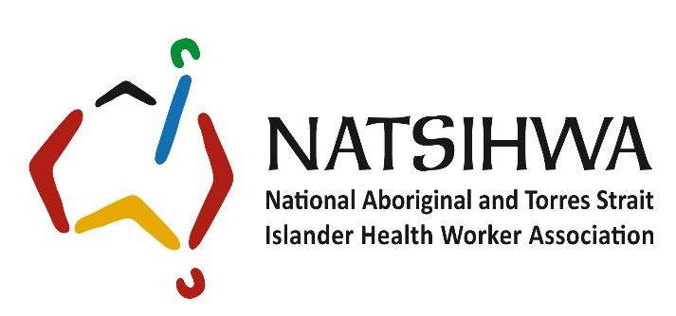

Job and Person Specification
Position: Project Officer -
Award: NATSIHWA Enterprise Agreement 2017
Level: Level 5 - $1385.49 – 1498.36 per week
Appointment: Contract to 30 June 2022, extension maybe subject to funding
Position Hours: 38 hrs per week permanent full-time
Updated: March 2019

Job specification

Position summary
The Project Officer undertakes identified projects to meet outcomes against NATSHIWA’s Strategic Plan including; policy development, analysing documents, review and advice, to progress NATSIHWA’s priorities, to support a strong and valued Aboriginal and Torres Strait Islander Health Worker and Health Practitioner workforce.
Broadly, the position:
- undertakes research and analysis, reviewing alternatives in relation to policy deliverables, to contribute to Organisational and Government policy processes and to inform decision making;
- provides a range of project management and support services, including preparation of discussion papers, briefs, submissions, progress and annual reports;
- contributes to the development and delivery of policy initiatives whilst preparing and reviewing policy advice to ensure alignment with NATSIHWA’s policy and strategic directions and priorities;
- work closely and in partnership with other national peak bodies , Registered Training Organisations (RTO’s) and other, key stakeholders; and coordinates working groups, committee meetings, and stakeholder consultations to support engagement as well as policy development and implementation;
- collates and analyses information for reporting, monitoring and evaluation purposes to contribute to the achievement of national policy outcomes for Aboriginal and Torres Strait Islander Health Workers and Health Practitioners.

Line management
The Policy Officer reports directly to the Chief Executive Officer and indirectly through to the Chief Operations Officer.

Special conditions
- This is a Canberra-based position with possible interstate travel.

Primary responsibilities include
- On behalf of the CEO and membership, interpret the National Aboriginal and Torres Strait Islander Health Plan and other relevant documents and develop policy responses as required.
- Identify and pursue opportunities for cooperation and collaboration with relevant stakeholders on initiatives aligned with NATSIHWA priorities.
- Assist with implementation of advocacy and promotion strategies in line with NATSIHWA priorities.
- Responsible for overseeing Projects including; Design, Implementation and Evaluation to ensure NATSIHWA is on track to meet agreed Projects.
- As required participate as an active member on the National Health Leadership Forum Policy network, interpreting and responding to received requests by developing NATSIHWA’s positions.
- Represent NATSIHWA on external working groups, committees, forums or events as delegated, and report on the outcomes.
- Support the development and implementation of the NATSIHWA three-year Strategic Plan, Annual Activity Plan, Annual Report and Evaluation Strategies.
- Support the development and implementation of the NATSIHWA Communication Strategy.
- Assist in identifying and implementing self-generating funding initiatives to support NATSIHWA’s sustainability into the future.

Person specification

Essential criteria

1. Personal abilities/aptitudes/skills
- Demonstrated ability to work with Aboriginal and Torres Strait Islander communities and their leaders, respecting cultural values and ways of doing business.
- Demonstrated ability to communicate effectively, both orally and in writing, to a wide range of audiences on a range of sensitive and complex issues, especially with regard to Aboriginal and Torres Strait Islander peoples.
- The ability to interpret and identify key information within policy and other relevant publications relevant to the sector and its members.
- Demonstrated ability to oversee Projects; Design, Development, Implementation and Evaluation from infancy to completion
- Demonstrated ability to work as a member of a team, identify performance outcomes, plan activities and set priorities to achieve agreed objectives and meet timelines.
- Demonstrated ability to appropriately exercise initiative and judgement, and recognise, mitigate and resolve conflict.
- As part of a small, dynamic team have the ability to think independently to influence change for the sector.
- Proven ability to work independently under broad direction.

2. Experience
- Experience in working with Aboriginal and Torres Strait Islander peoples, organisations and communities in the health sector.
- Experience in the use of information technology, including word processing packages, electronic mail, databases, spread-sheets and PowerPoint presentations.

3. Knowledge
- Knowledge and understanding of the current issues impacting on Aboriginal and Torres Strait health and wellbeing from both an historical and political perspective.
- Understanding and demonstrated commitment to, the principles and practices of equity, diversity and OH&S in the workplace

4. Qualifications
- A qualification or extensive experience in Public Health or Public Policy or simular.

Desirable criteria

1. Qualifications
A post-graduate qualification in Public Health or Public Policy.

Selection criteria and process
In applying for this job we need you to provide two documents:
- An up to date Curricula Vita (CV) that includes the names and contact details for two referees from recent positions you have held – please be aware that we may request a written reference.
- A maximum 3-page letter outlining your response to the following five questions that demonstrate your experience in:
  - ability to perform the job
  - how you meet the all of the essential and any of the desirable criteria in the person specification:
- What work have you undertaken in Aboriginal and Torres Strait Islander contexts? How would this work relate to this position?
- What is your experience in developing and responding to managing Projects including responding to policy positions and/or initiatives within the not for profit sector or federal or state government sector? How will your experience value add to NATSIHWA?
- How would you describe you experience, skills and confidence in using information and communication technologies?
- Describe your experience in communicating and engaging with a diverse range of stakeholders. How do you see these skillsets being of benefit to NATSIHWA?
- What values and commitments do you hold in working independently and in a multidisciplinary team within a small organisation?
Once you have completed your letter of response and attached your CV please forward onto Julie Guest eo@natsihwa.org.au
If you require further information please contact Julie on (02) 6221 9221.

